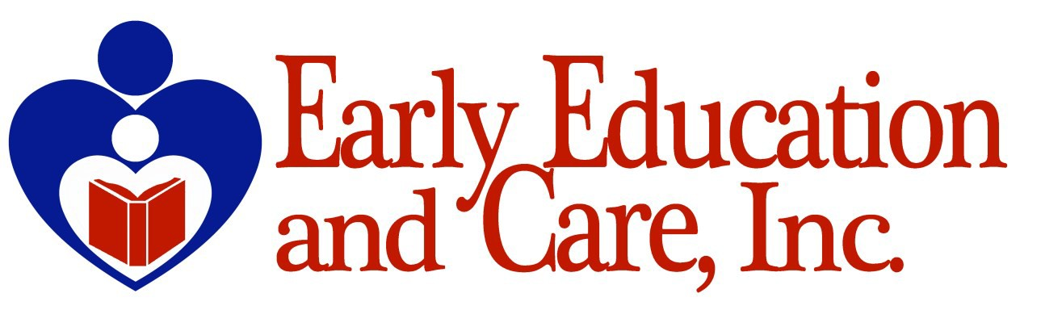

Invites You To The

Head Start

28TH ANNUAL







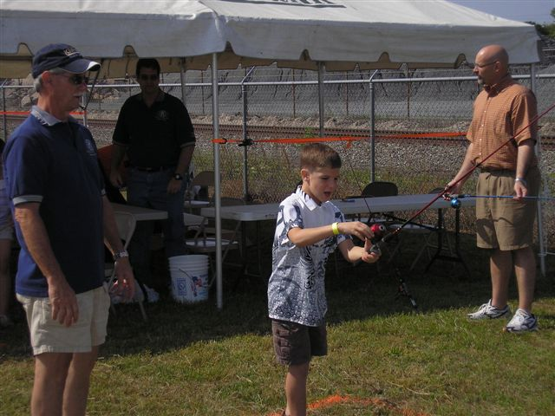

**Saturday, April 26, 2025**

**10:00 a.m.-3:00 p.m.**

**Central Panhandle Fairgrounds**

**Free Admission**



**Food**

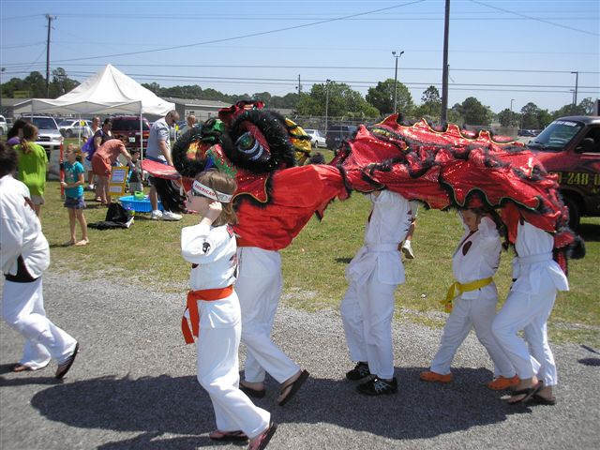

**Fun**

**For More Information, call:**

**850.818.9003 x 1007, 1001, or 1000**

